Homework 5

# Answers

1. N.A.
2. What would be the respective result of the *print* if the parameter *a* of *foo* is passed by
   1. Value
      1. 10
   2. Reference
      1. 15
   3. Value-result
      1. 15
   4. Result
      1. 5
3. Consider the following program where foo uses pass by value for a:
   1. Static memory for global variable “m”. “x” and “a” are in stack.
   2. 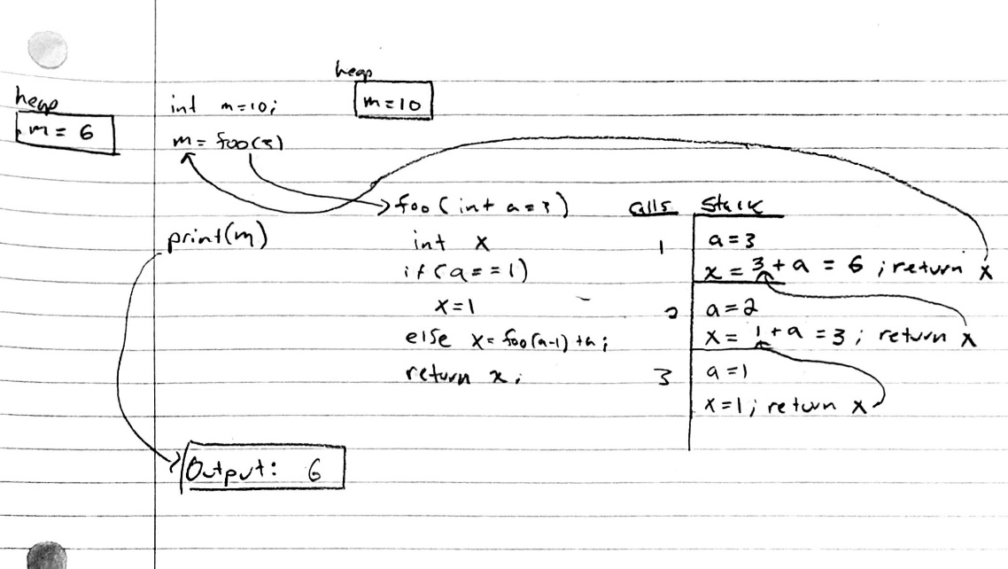
4. Lisp. Please refer to Q4.lisp.txt. Also, please note that the function name “*max*” is already defined. It is now called *max1*.